**ASSIGNMENT 2 FRONT SHEET**

|  |  |  |  |
| --- | --- | --- | --- |
| **Qualification** | **BTEC Level 5 HND Diploma in Computing** | | |
| **Unit number and title** | Unit 06: Managing a Successful Computing Project | | |
| **Submission date** | 23/05/2021 | **Date Received 1st submission** |  |
| **Re-submission Date** | 30/05/2021 | **Date Received 2nd submission** |  |
| **Student Name** | PHAM CAO NGUYEN | **Student ID** | GCC18074 |
| **Class** | GCC0801 | **Assessor name** | TRUNG-VIET NGUYEN |
| **Student declaration**  I certify that the assignment submission is entirely my own work and I fully understand the consequences of plagiarism. I understand that making a false declaration is a form of malpractice. | | | |
|  |  | **Student’s signature** | CAONGUYEN |

**Grading grid**

|  |  |  |  |  |  |
| --- | --- | --- | --- | --- | --- |
| P5 | P6 | P7 | M3 | M4 | D2 |
|  |  |  |  |  |  |

|  |  |  |
| --- | --- | --- |
| **❒ Summative Feedback: ❒ Resubmission Feedback:** | | |
| **Grade:** | **Assessor Signature:** | **Date:** |
| **IV Signature:** | | |

**ASSIGNMENT 2 BRIEF**

|  |  |  |  |
| --- | --- | --- | --- |
| **Qualification** | **BTEC Level 5 HND Diploma in Computing** | | |
| **Unit number and title** | Unit 06: Managing a Successful Computing Project | | |
| **Assignment title** | Present results and reflect the value gained | | |
| **Academic Year** | 2020 – 2021 | | |
| **Unit Tutor** | HOANG Nhu Vinh | | |
| **Issue date** | 29 Sep 2020 | **Submission date** | 29 Sep 2020 |

|  |
| --- |
| **Submission Format:** |
| *Format:* The submission is in the form of an individual written report and presentation report. This should be written in a concise, formal business style using single spacing and font size 12. You are required to make use of headings, paragraphs and subsections as appropriate, and all work must be supported with research and referenced using the Harvard referencing system. Please also provide a bibliography using the Harvard referencing system.  *Submission* Students are compulsory to submit the assignment in due date and in a way requested by the Tutors. The form of submission will be a soft copy in PDF posted on corresponding course of <http://cms.greenwich.edu.vn/>.  *Note:* The Assignment *must* be your own work, and not copied by or from another student or from  books etc. If you use ideas, quotes or data (such as diagrams) from books, journals or other sources, you must reference your sources, using the Harvard style. Make sure that you know how to reference properly, and that understand the guidelines on plagiarism. *If you do not, you definitely get fail* |
| **Assignment Brief and Guidance:** |
| **Scenario**: Continued from Assignment 1.  **Tasks**  You have done the research and have the answer for the company problem. It’s time to do a presentation of the results of your research in front of the board of directors. Results should be analysed and appropriate recommendation should be drawn from that.  Finally, you need to write a brief report to QA department to reflect the whole project process. The report should include:  - Logbooks, lessons learnt, reflection of project outcomes and project process  - Critical evaluation of the selection of appropriate research tools and techniques for accuracy and authenticity  - Critical evaluation of project management plan and process applied on the project |
|  |

|  |  |  |
| --- | --- | --- |
| **Learning Outcomes and Assessment Criteria** | | |
| **Pass** | **Merit** | **Distinction** |
| **LO3** Present the project and communicate appropriate recommendations based on meaningful conclusions drawn from the evidence findings and/or analysis | | **LO3 & 4**  **D2** Critically evaluate and reflect on the project outcomes, the decision making process and of the initial project management plan to support justification of  recommendations and learning during the project. |
| **P5** Analyse research and data using appropriate tools and techniques.  **P6** Communicate appropriate  recommendations as a result of research and data analysis to draw valid and meaningful  conclusions. | **M3** Evaluate the selection of appropriate tools and techniques for accuracy and authenticity to support and justify recommendations. |
| **LO4** Reflect on the value gained from conducting the project and its usefulness to support sustainable organisational performance | |
| **P7** Reflect on the value of undertaking the research to meet stated objectives and own learning and performance. | **M4** Evaluate the value of the project management process and use of quality research to meet stated objectives and support own learning and performance. |

Contents

Part 1. Present the project and communicate appropriate recommendations based on meaningful conclusions drawn from the evidence findings and/or analysis. 6

**1.** **Analyse research and data using appropriate tools and techniques.** 6

**2.** **Communicate appropriate recommendations as a result of research and data analysis to draw valid and meaningful conclusions.** 13

**3.** **Recommendations.** 19

Part 2. Reflect on the value gained from conducting the project and its usefulness to support sustainable organisational performance. 20

**1.** **Reflections** 20

**2.** **Evaluations.** 23

References 24

# Part 1. Present the project and communicate appropriate recommendations based on meaningful conclusions drawn from the evidence findings and/or analysis.

1. **Analyse research and data using appropriate tools and techniques.**

* There are many methods for us to do a qualitative and quantitative survey using google or by direct interview, especially the low risk and easy-to-use google form for all of us.

1. **Introduction Google form[1].**

* Google Forms is an online data collection tool that integrates easily and efficiently with other Google Products. It provides an easy way to create forms in a matter of minutes and without writing a single line of code. (Brock, 2020)
* How to use Google Forms?
* Go to the link: <https://docs.google.com/forms/>
* Create a New Form: Click on the “+” icon. It will take you to the New Form Screen. If you don’t want to start with a blank form, you can choose one of the templates available as per your requirement.

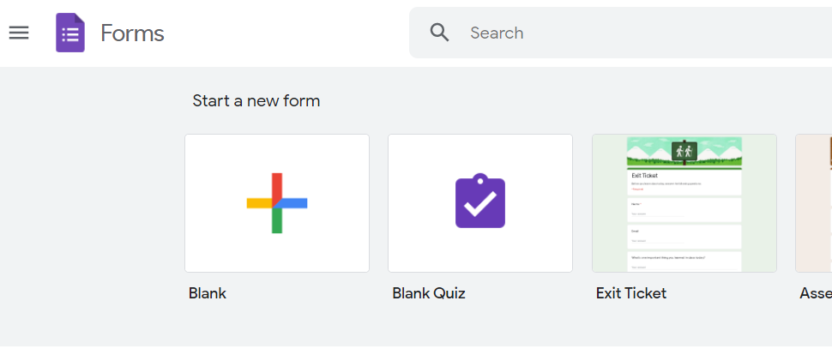

**Figure 1: Home page Google Forms.**

* Save your Form: Click on the untitled form and rename it to save it.
* Customize the Form: Add Form description, though it is optional, it is advisable to use it. Select the theme, background color, and font style to customize it.
* Add Elements: Add questions to the form, select the question type, and add response options & Validations to each question.
* Edit Form: You can reorder & delete questions, add a description or hint to the questions, and can shuffle the answer order. You can also add images or videos to a question.

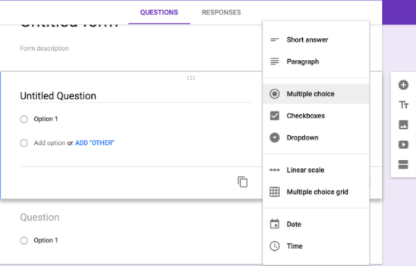

**Figure 2: Edit form of google form.**

* Choose Form Settings: Implement settings to the form such as who can access the form, collect Email Address, whether to send Response Receipts, etc.
* Share for review: Invite People to review your form. Under “Invite People” add email addresses and send the invitation.
* Preview: Preview your form, edit it if required, and save.
* Send Form: You can send the form directly through Email or a customized link. This form can also be shared on Social Media and can be embedded into the website in specified inline frames.
* Analyze Responses: Click on the Responses tab to check the responses report, click on the email address to check the individual response.
* Export Data: You can Print the Form and can download the Responses as a CSV File.

**Advantages of using Google forms:**

* It is a free online tool, that allows you to collect information easily and efficiently.
* With Google forms, you can create surveys in few minutes to ask your clients or collaborators information about your products or service.
* To start using this tool, you only need a Google account, the same one you need to access Gmail, YouTube, or Google Drive.
* The interface is very easy to use. Any user with average Internet knowledge can create forms using this tool.
* The assistant is simple to use. The What-You-See-Is-What-You-Get interface makes it easy to drag and drop form elements and organize them based on actions or events.
* At the design level, it is possible to choose between a palette of colors, as well as own images as a background.

**Disadvantages of using Google forms:**

* It is necessary to have the internet to be able to use this tool.
* The design customization is very limited. Advanced users can change the design to use the tool for a greater number of purposes.
* There are some security concerns. The user has to create a good password and protects it to increase the level of security.
* There are certain limitations regarding the capabilities of this tool. It accepts texts up to 500 Kb; images up to 2 Mb; and for spreadsheets, the limit is 256 cells or 40 sheets.

**Why use google form?**

* It is very user-friendly to implement. You can create surveys, quiz forms with multiple choice questions, drag-and-drop type questions, registration forms, opinion polls, etc.
* Google forms can facilitate contact with your customers or with your organization members and it is very helpful to gather the information that might allow you to have greater control of your company’s production and distribution processes. It can also help you to see and analyze your workers’ performance.

1. **Qualitative**

* **Introduction2.** 
  + - The modes of data collection for qualitative research are quite varied and often do not have a specific structure like quantitative research. Some of the methods can be mentioned such as focus group, personal interview, and observation. Samples of this method are usually small and are more carefully selected.
    - Qualitative research relies on data obtained by the researcher from first-hand observation, interviews, questionnaires, focus groups, participant-observation, recordings made in natural settings, documents, and artifacts. The data are generally nonnumerical. Qualitative methods include ethnography, grounded theory, discourse analysis, and interpretative phenomenological analysis. Qualitative research methods have been used in sociology, anthropology, political science, psychology, social work, and educational research. Qualitative researchers study individuals’ understanding of their social reality.
    - A central issue in qualitative research is trustworthiness (also known as credibility or, in quantitative studies, validity). There are many ways of establishing trustworthiness, including member check, interviewer corroboration, peer debriefing, prolonged engagement, negative case analysis, auditability, confirmability, bracketing, and balance. Data triangulation and eliciting examples of interviewee accounts are two of the most commonly used methods of establishing the trustworthiness of qualitative studies. (Flick, 2018)
* During the development of the project, we have a survey of our system. It is based on the actual needs of customers through qualitative research. Currently, some farms are using the equipment. There are many advantages and also some downsides to its drawbacks through some of our qualitative research survey questions about some of the farms in use.

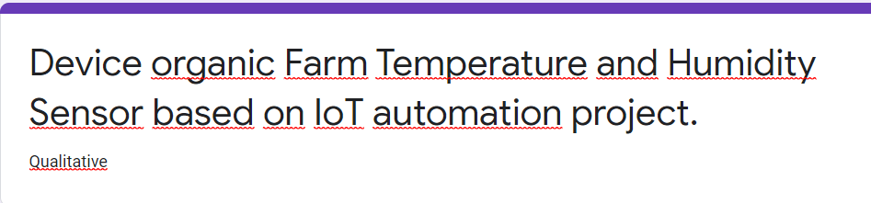

**Figure 3: Qualitative research.**

* **Question 1:** Is this project really more convenient than manual temperature measurement?
* To the question “Is this project really more convenient than manual temperature measurement?” We have chosen to answer “Linear scale” with 5 levels from “1 Unconvenient” to “5 Very convenient” to see if it is really more convenient to measure humidity temperature with the device than manually. In figure 4.

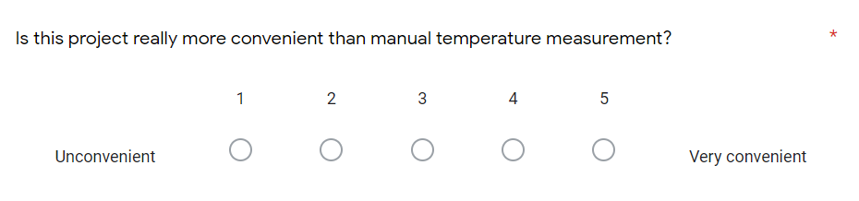

**Figure 4: Question number one qualitative research.**

* **Question 2:** Does this device give you satisfaction?
* This is a question to know customer satisfaction with the device.
* This question had 4 answers on a level of “Very pleased” “Convenient” “Unsatisfied” “Very bad” let us know the customer satisfaction with the equipment. In figure 5.

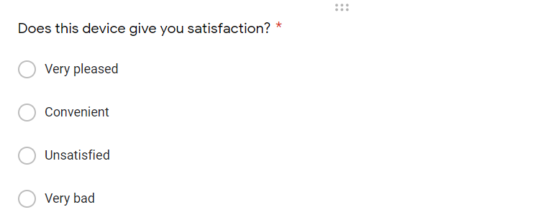

**Figure 5: Question number two qualitative research.**

* **Question 3:** Is the price of the equipment appropriate?
* Why did we choose the question “Is the price of the equipment appropriate?” This is because, from that, we make a judgment that this equipment is suitable for small and medium-sized farms without investment capital. In figure 6.

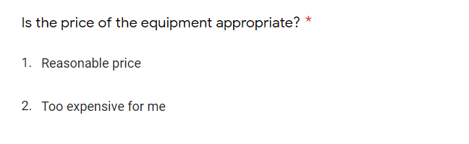

**Figure 6: Question number three qualitative research.**

* **Question 4:** Does equipment installation help increase farm productivity?
* This question examines the quality of equipment with customers. Will installing equipment help increase farm productivity? In figure 7.

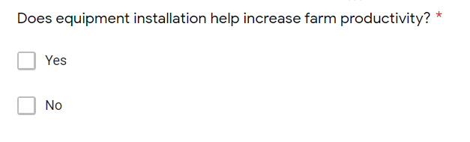

**Figure 7: Question number four qualitative research.**

* **Question 5:** Would you recommend our product to your friends?
* Would you recommend our products to your friends? Through this question to know the trust of customers for the device. In figure 8.

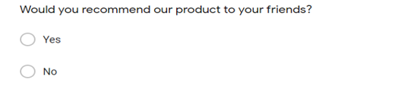

**Figure 8: Question number five qualitative research.**

* **Question 6:** What are the disadvantages when are you using this sensor device?
* A question about disadvantages a customer faces when using equipment on their farm. To see if the device is operating properly through different weather patterns and conditions. In figure 9.

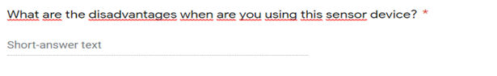

**Figure 9: Question number six qualitative research.**

1. **Quantitative.**

* **Introduction.3**
  + - The quantitative research method is the collection and analysis of information on the basis of data collected from the market. The purpose of quantitative research is to draw market conclusions through the use of statistical methods to process data and data.
    - Quantitative research is a research strategy that focuses on quantifying the collection and analysis of data. It is formed from a deductive approach where emphasis is placed on the testing of theory, shaped by empiricist and positivist philosophies.
    - Quantitative data is any data that is in numerical form such as statistics, percentages, etc. The researcher analyses the data with the help of statistics and hopes the numbers will yield an unbiased result that can be generalized to some larger population. Qualitative research, on the other hand, inquires deeply into specific experiences, with the intention of describing and exploring meaning through text, narrative, or visual-based data, by developing themes exclusive to that set of participants. (Hoy, 2015)
* During the development of the project, we have a survey of our system. It is based on the actual needs of customers through quantitative research. Currently, some farms are using the equipment. There are many advantages and also some downsides to its drawbacks through some of our quantitative research survey questions about some of the farms in use.

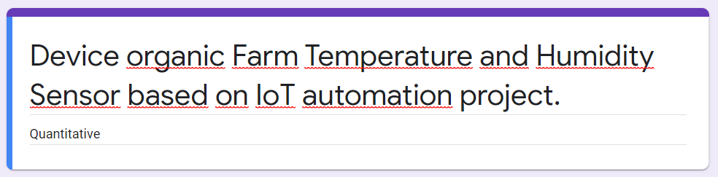

**Figure 10: Quantitative research.**

* **Question 1:** The level of customer satisfaction with the device
* Survey on customer satisfaction with equipment. As the chart below shows that the majority of customers are satisfied with the device and very satisfied with the device. Expressed through 10 levels “1 is Unsatisfied” to “10 is Very pleased”. To know how satisfied customers are with the device. In figure 11.

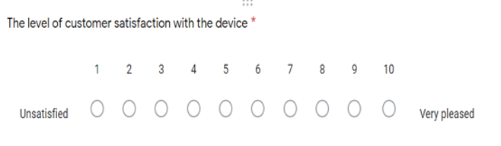

**Figure 11: Question number one quantitative research.**

* **Question 2:** The safety of the system
* We want to know if the customer feels safe when using the device. Quality and safety are our top priorities. In figure 12.

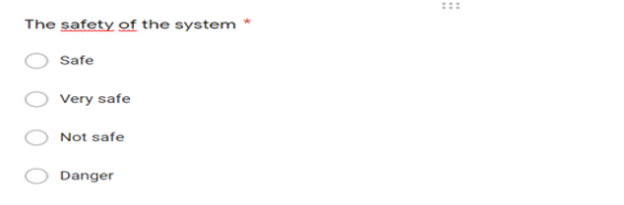

**Figure 12: Question number two quantitative research.**

* **Question 3:** Did you really find it good after using the device?
* Through this question, we want to know the change of customers from manual measurement to adopting IoT for their farm. Showed that the convenience and accuracy of the equipment and use were very good. In figure 13.

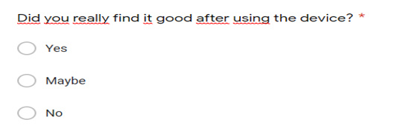

**Figure 13: Question number three quantitative research.**

* **Question 4:** Temperature sensor speed, humidity quickly
* Speed is the most important thing, that's why we created measuring equipment. Helps measure temperature, humidity as well as self-regulate the climate as quickly as possible to prevent some natural disasters like climate change like today. By manual measurement, it gives both slow speed and low accuracy. In figure 14.

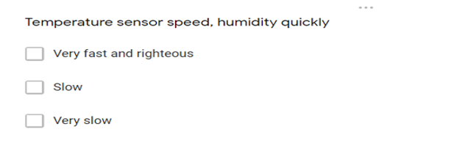

**Figure 14: Question number four quantitative research.**

* **Question 5:** Equipment accuracy
* According to each type of climate, the temperature and humidity of each place are different, so we want to know if the device has the correct temperature and humidity adjustment for each place. In figure 15.

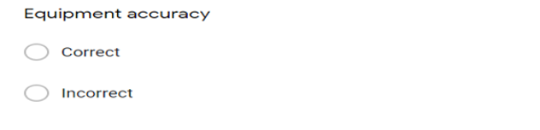

**Figure 15: Question number five quantitative research.**

* **Question 6:** User opinion about the device
* We want to know the customer,s opinion about the device and from there we can improve the device to better serve the needs of the customer. In figure 16.

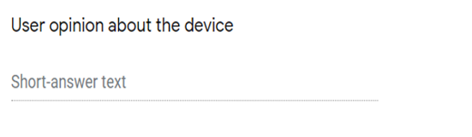

**Figure 16: Question number six quantitative research.**

1. **Communicate appropriate recommendations as a result of research and data analysis to draw valid and meaningful conclusions.**
2. **Qualitative**

* **Present**
* **Question 1:** Is this project really more convenient than manual temperature measurement?
* From question number one we have a chart.
* For the first question we prioritized in terms of quality and whether the equipment performance was really better than with manual work, then 5 out of 10 farms were selected at (number 4). Specific figures are shown in the chart below.
* Through the survey, we found the convenience of the device because that no one chose unconvenient, as well as 0%, chose number 1. In figure 17.

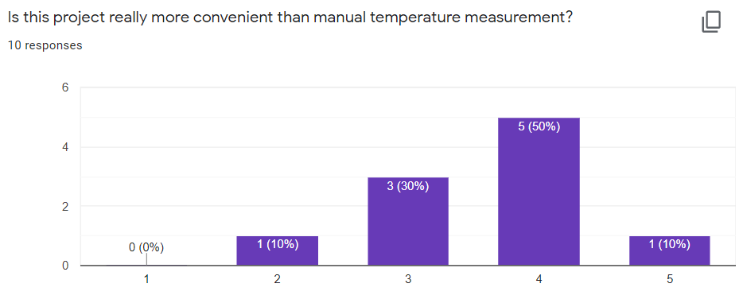

**Figure 17: Column chart showing device convenience.**

* **Question 2:** Does this device give you satisfaction?
* From question number two we have a chart.
* As shown in the chart below shows that 90% / 100%, as well as 9 out of 10 surveyed people, choose “Very pleased” and “convenient” and very few choose “Very bad”. The chart shows that the device has brought great satisfaction to the customer, and while there is some dissatisfaction, we will try to find a way for the customer to fix this problem. In figure 18.

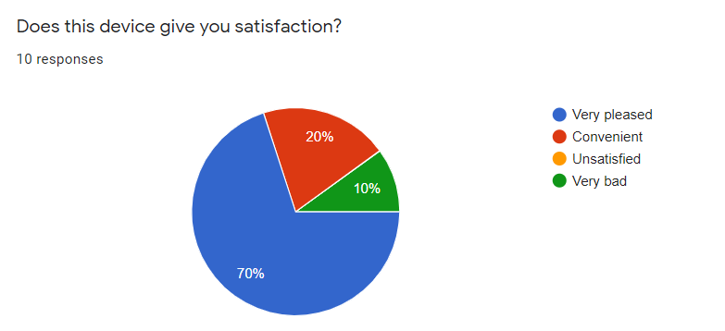

**Figure 18: Pie chart showing customer satisfaction with the device.**

* **Question 3:** Is the price of the equipment appropriate?
* From question number three we have a chart.
* This question is to survey the price of the device to the customer. Through the survey, 50%/50% of customers rate the device as “Reasonable price” and vice versa, they rate it as “Too expensive for me”. from that, we make a judgment that this equipment is suitable for small and medium-sized farms without investment capital. In figure 19.

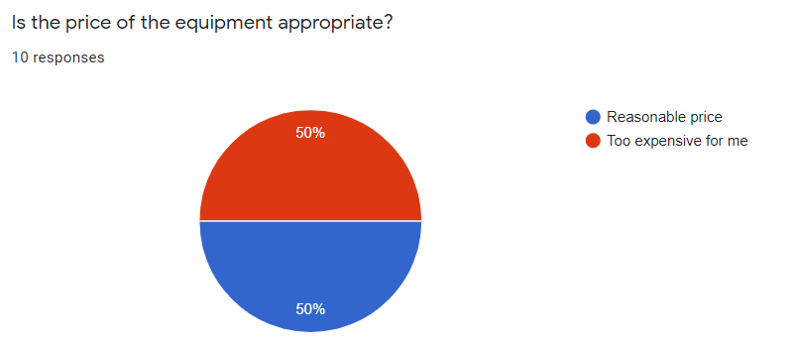

**Figure 19: The graph depicts the device’s cost to the consumer.**

* **Question 4:** Does equipment installation help increase farm productivity?
* From question number four we have a chart.
* Follow the actual data and display on the chart showing that the installation and use of equipment increase the productivity of the farm as evidenced by the fact that more than 90% are using equipment that has increased productivity. In figure 20.

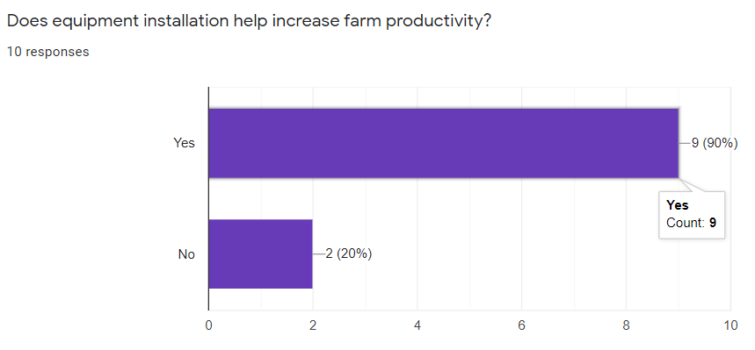

**Figure 20: The graph shows the productivity of the device.**

* **Question 5:** Would you recommend our product to your friends?
* From question number five we have a chart.
* Through questions and graphs, it shows that more than 50% of people are really satisfied with the device and want to widely recommend it to their friends. In figure 21.

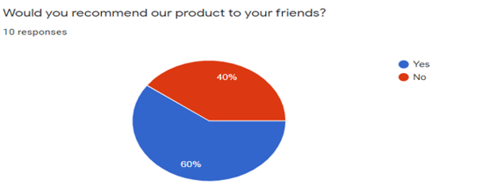

**Figure 21: The graph shows the percentage of customers who would recommend our device.**

* **Question 6:** What are the disadvantages when are you using this sensor device?
* From question number six we have a chart.
* All customers using the device are satisfied and have no disadvantages when using the device. In figure 22.

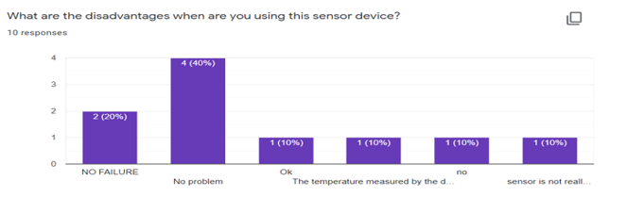

**Figure 22:** **Chart when the customer uses the device and the disadvantages.**

* We have a list of customer responses to the Qualitative survey questions above.
* We found that almost all of the customers who used the device were very pleased with the convenience and accuracy as well as the level of customer satisfaction with the device through the actual reviews we obtained at Questions and the chart above. In figure 23.

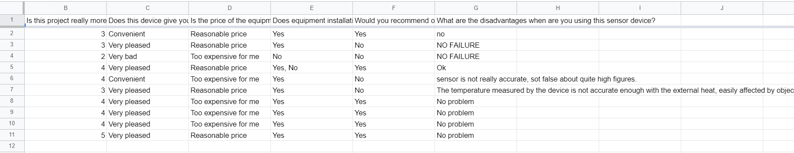

**Figure 23: Qualitative data actual reviews**

1. **Quantitative**

* **Present**
* **Question 1:** The level of customer satisfaction with the device
* From question number one we have a chart.
* Survey results show that customers are very satisfied with the device, only 1 of 12 people are not really satisfied with the device as shown in the chart below. In figure 24.

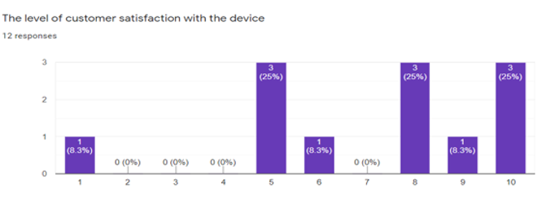

**Figure 24: The graph shows the level of customer satisfaction.**

* **Question 2:** The safety of the system
* Survey questions about the safety of equipment through the chart show that only 8.3% out of 100% consider it dangerous. This shows that the safety of the equipment is very high and quality. In figure 25.

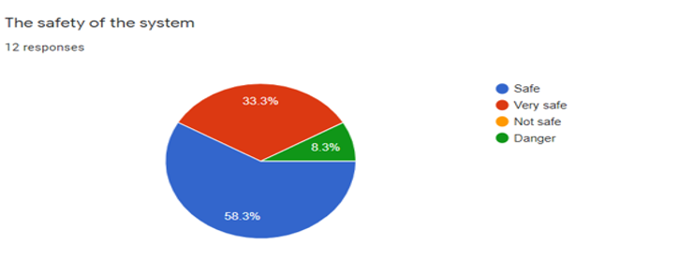

**Figure 25: The graph shows the safety level of the device.**

* **Question 3:** Did you really find it good after using the device?
* Stars when put into use using the equipment, we get the results from the survey, the majority of which account for more than 90% of customers who use the equipment for the farm, all of which are effective is very good, as shown by the data in the chart below. In figure 26.

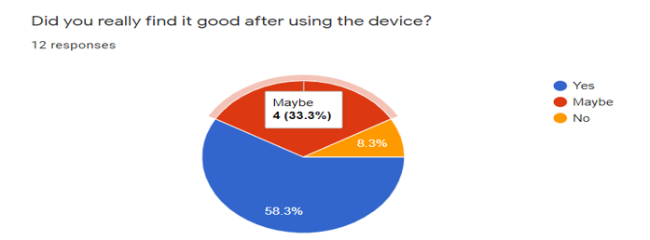

**Figure 26: The graph shows the star results when the customer uses the device.**

* **Question 4:** Temperature sensor speed, humidity quickly
* As shown in the chart, more than 50% of the farms have applied temperature and humidity measurement equipment for the survey results. The device works as well as measures temperature and humidity very quickly. In figure 27.

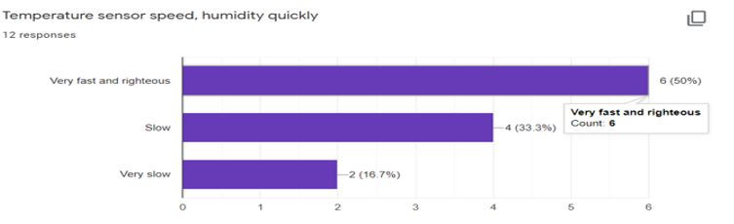

**Figure 27: The graph shows the working speed of the device.**

* **Question 5:** Equipment accuracy
* Through the survey question “Equipment accuracy” for the device. The majority of customers have installed the device and said that the accuracy is high. The graph shows that 75% of customers choose “Correct”. In figure 28.

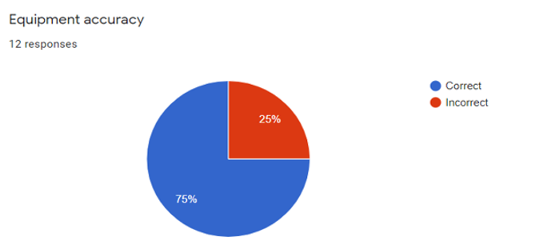

**Figure 28: The graph shows the accuracy of the device.**

* **Question 6:** User opinion about the device.
* Through the chart below we can see. The customer opinion of the device is very good and achieved customer satisfaction and no problems when using the device. In figure 29.

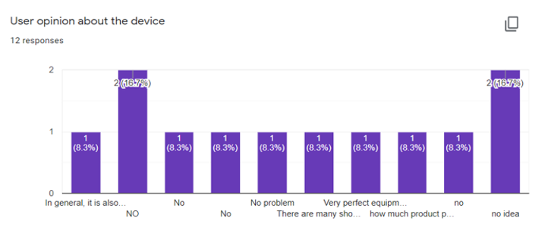

**Figure 29: The chart shows the customer’s opinion with the device.**

* But aside from that, there are still certain restrictions that we haven’t done well yet. This feedback will help us strengthen our device (Data is collected via google form).
* The actual implementation of the system may be costly in terms of installation and annual maintenance. If applying the long-term system, the initial cost is not much compared to hiring more permanent workers. The aim of automation is also to deploy this device more conveniently and more rapidly. In figure 30.

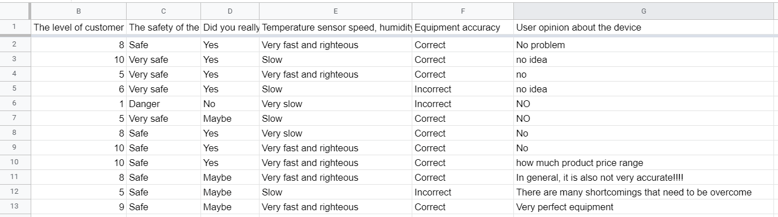

**Figure 30: Quantitative data actual reviews**

1. **Recommendations.**

**Summary about your proposed system**

* Their idea is to build a framework for measuring temperature and humidity in the air applied on the farm. It has been established that SMART agricultural technology helps to monitor farming. The aim has been to initiate better crop production thus innovating the landscape of existing farming methods. Mainly sensor-based methods are known to calculate air volume, temperature, humidity, and vegetation as well as organism growth. IoT can help more in detecting and purifying this air as well as temperature and humidity with the help of sensors to analyze and report changes in plants, leaves, and soil.

**List of features for your proposed system**

* The project will track temperature and humidity measurements and adjust to the organisms inside the farm.
* Can sense the temperature and humidity of the air.
* Can automatically filter the air
* Can even adjust the temperature to suit the organism inside.
* Automatically adjusts humidity.
* We can control the internal temperature by voice
* The system can connect to all software and applications, even on smartphones
* The system is always updated with the temperature and humidity will be displayed on all devices

**Give advantages and disadvantages of your proposed system**

* **Advantages of the devices.**
* During the implementation of the project, we assess the outstanding advantages in terms of speed, precision, scalability, and, in particular, customer satisfaction through actual surveys.
* Sensing speed is fast and more accurate than manual measurement.
* Devices it is very safe when used, and can sense temperature and humidity continuously.
* The equipment can be used in all different climates and all kinds of farms.
* **Disadvantages of the devices.**
* Besides, the equipment also has some disadvantages that need to be improved in the near future, that is, the cost of the equipment is quite high for some farms without investment capital.
* Still, a small part of customers using the device said that the accuracy of the device is not high, through the survey question Figure 28.
* There are also some customers who said that the sensor equipment is very slow, like the actual survey question in Figure 27. We will solve and improve it for customers as soon as possible.

# Part 2. Reflect on the value gained from conducting the project and its usefulness to support sustainable organisational performance.

1. **Reflections**

* **Schedule**
* We have the schedule figure 31 presented in assignment 1, and from there we have the logbook.

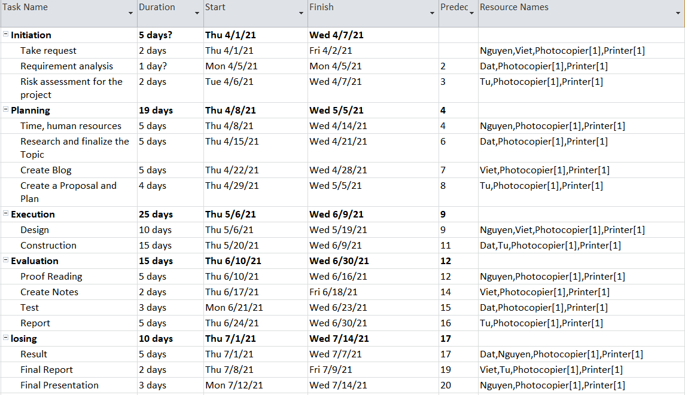

**Figure 31. Schedule for project**

* **Logbook**
* We use the schedule presented in assignment 1.

|  |  |  |  |  |  |
| --- | --- | --- | --- | --- | --- |
| **Device organic Farm Temperature and Humidity Sensor based on IoT automation project** | | | | | |
| **Begin date: 01/04/2021** | | | | **Target ending: 14/07/2021** | |
| **Scheduled** | | **Actual** | | **Task action list** | **Problem** |
| **Begin** | **End** | **Begin** | **End** |
| 01/04/2021 | 04/07/2021 | 01/04/2021 | 04/07/2021 | Initiation: start the project we have to collect requirements analysis and risk assessment for the project | In the process of doing risk calculation, there are some real-world false predictions. These risks have been detected for the time being and did not affect the project implementation. |
| 08/04/2021 | 05/05/2021 | 08/04/2021 | 05/05/2021 | Planning: First, we set up the time and allocation of human resources, Research and finalize the topic, create a blog, create a proposal and plan for the project. | There were still problems with human resources, but it was fixed and did not affect the progress of the project |
| 06/05/2021 | 09/06/2021 | 06/05/2021 | 09/06/2021 | Execution: Mainly design and build to complete the project | No problem |
| 10/06/2021 | 30/06/2021 | 10/06/2021 | 30/06/2021 | Evaluation: After completing the project to make it work well, we have to evaluate the project by: Proof Reading, Create Notes to record the weak points of the project and improve, Test and Report. | No problem |
| 01/07/2021 | 14/07/2021 | 01/07/2021 | 14/07/2021 | Losing: Finally, the project is summarizing and completing the project to hand over and put into operation | No problem |

**Table 1: Project Logbook**

* This research project has provided a brilliant result in the development of temperature and humidity sensor systems. The goals set have been successfully implemented. Also, there are errors in execution, but the era has been discovered and the best solution would not impact the implementation of the project. Expectations for this project are also met with the following proposals: Sensing speed is fast and more accurate than manual measurement, devices it is very safe when used, and can sense temperature and humidity continuously, the equipment can be used in all different climates and all kinds of farms.
* This study demonstrates the importance of smart farms in the future. Bringing the internet to life is a big turning point for agricultural development.
* The introduction of artificial intelligence to life is a big turning point. Artificial intelligence allows computers to develop human intelligence, such as thought and reasoning to solve problems, interacting through understanding language, speaking, learning and adapting, etc. Artificial intelligence relates to the actions, learning, and intellectual adaptability of computers.
* The lesson we learn from the project process is to select data that must be practical with the goals that the project originally set out. Through the process of doing surveys, we realize that the thinking and desire of current customers are that they want to experience advanced technologies and want those technologies to be applied to our models and project judgment around their life.
* Through field surveys, customers are very satisfied with the project and very welcome. However, there are some cases due to no cost...

1. **Evaluations.**

* **Evaluate the success of the project:**
* The research project has been completed as originally planned. Besides, a few errors were made during the implementation of the project (Table 1). Danger estimation and data collection faced a variety of difficulties but varied from time to time, and the project was completed on time. It was a great success because there were challenges, but there was always a way to fix them.
* The project lasted for 3 months and was 100% successful and there were risks in the implementation process that was generally negligible and did not affect the project much, the project was successful on time.
* **Done in the plan:**
* The project has a deadline to complete: As a result, we’ve organized each activity for each time slot and implemented them in the order that was established before. We’ve done each particular job sequentially. Enable the work to be completed smoothly. All project goals have been successfully achieved through the implementation of project management strategies.
* My direct job is managing time allocation and planning, collecting requirements from customers, allocating work to team members, and meet customers, assess and analyze risks as well as human resources and project implementation costs.
* **Constraints when implementing the plan:**
* In the course of implementing the research project, except for the effects listed in Table 1, other factors are influencing the implementation of the project. Weather and human factors also have a major effect on the implementation process. There are also some solutions to avoid the factors influencing the implementation process due to the problems described above.

# References

[1] Brock, A., 2020. *Introduction to Google Classroom*. Simon and Schuster.

[2] Flick, U., 2018. *An introduction to qualitative research*. sage.

[3] Hoy, W.K. and Adams, C.M., 2015. *Quantitative research in education: A primer*. Sage Publications.

[4] Schwalbe, K., 2009. *Introduction to project management*. Boston: Course Technology Cengage Learning.

1. Brock, A., 2020. *Introduction to Google Classroom*. Simon and Schuster.